**Digital Parking System**

# PRODUCT AND PROJECT DESCRIPTION

## System Features

1. **Find rent:**

**Functional Requirements**

* 1. By using digital parking system apps at first we have to find rent user need to click the search areas where map show free space
  2. When we found free space or garage after that we have to send the request to the receiver if receiver confirm sender request after that, then they find rent for they or their Vehicles.

*Priority Level: High/Medium/Low*

*Precondition:*

*Cross-reference:*

1. **Payment:**

**Functional Requirements**

When a receiver confirm request .After that users find a option in the apps where he or she give payment via online or hand. If she /he want they give money by bikash or hand .I think a digital online payment is much easier and safety then others .so we would like to introduce a digital payment in our apps.

*Priority Level: High/Medium/Low*

*Precondition:*

*Cross-reference:*

1. **Reward:**

**Functional Requirements**

In our digital parking system app we would like to use rewards system it’s like when a user park a garage more than 20 time in a month they find 1 free parking. It’s like a gift of one time free parking .In ours apps there is a option where user can collect their reward point .By the reward point they find extra time free parking also.

*Priority Level: High/Medium/Low*

*Precondition:*

*Cross-reference:*

1. **Help service:**

**Functional Requirements**

* 1. This software should provide help button also.
  2. This help button will work as an emergency phone call to receiver when user face any problem they can help from help button by this way user can find better service and find released from any issue.

*Priority Level: High/Medium/Low*

*Precondition:*

*Cross-reference:*

1. **Profile:**

**Functional Requirements**

* 1. When users login the apps then they find his/her profile where users can find message button, reward button, help button and also settings button and also an account profile where he/she find his/her all information.
  2. And if user need to change any personal information then they need to go to profile after that they can change information.

*Priority Level: High/Medium/Low*

*Precondition:*

*Cross-reference:*

1. **Settings:**

**Functional Requirements**

* 1. This software also settings button where user can change their full information.
  2. If user want to change his/her account number, name, details, vehicles number and picture they can change by settings.

*Priority Level: High/Medium/Low*

*Precondition:*

*Cross-reference:*

## System Quality Attributes

**QA 1 - Availability:**

The system shall be at least 98 percent available on weekdays between 6:00 a.m.

To 09:30 p.m. and at least 96.8 percent available on between 09:30 p.m. to 2:00 a.m. local time.

*Priority Level: High*

*Precondition: N/A*

*Cross-reference:* ***QA – 3, QA – 5, QA 2***

**QA – 2. Integrity**

Example:

IN-1. Only Auditor shall be able to view customer transaction histories and their personal information.

*Priority Level: High*

*Precondition: N/A*

*Cross-reference:* ***QA – 3, QA – 4, QA 7***

**QA 3- Performance:**

Every Web page shall download in 6 seconds or less over a 60 kbps modem connection.

Updating data between 5 seconds and also web page refresh load should happen 8-9 seconds.

*Priority Level: Medium  
Precondition: N/A  
Cross-reference:* ***QA – 4, QA 1***

**QA – 4 Efficiency:**

At least 20 percent of the processor capacity and RAM available to the application shall be unused at the planned peak load conditions.

*Priority Level: High  
Precondition: N/A  
Cross-reference:* ***QA – 4, QA 1***

**QA – 5 Flexibility:**

A maintenance programmer who has at least five months of experience supporting this product shall be able to modify and test into the system with no more than two hours.

*Priority Level: Medium  
Precondition: N/A  
Cross-reference:* ***QA – 3, QA – 5, QA 7***

**QA 6- Portability:**

RU-1. The software can easily transfer from one environment to another.

For example –windows, Android, Apple, Linux, UNIX, Ubuntu, Haiku etc.

*Priority Level: Medium*

*Precondition: N/A*

*Cross-reference:* ***QA 3***

**QA 7- Testability**

The largest Cyclamate complexity will not exceed 20

*Priority Level: Medium*

*Precondition:* ***QA – 3, QA 8***

*Cross-reference: N/A*

**QA 8 – Reliability**

Example: RE-1. No more than 07 experimental runs out of 2000 can be lost because of software failure

*Priority Level: Medium*

*Precondition: N/A*

*Cross-reference:* ***QA – 3***

**QA 9– Robustness**

Example: RO-1. If the editor fails before the user saves customer transaction file, the editor shall be able to recover all changes made in the file being edited up to one minute prior to the failure the next time the same user starts the program.

*Priority Level: Medium*

*Precondition: N/A*

*Cross-reference:* ***QA 10, QA 03***

**QA 10-Maintainability**

Example: A maintenance programmer who has at least who has at least 6 months of working experience can solve any problem like-User failed to log in or can’t upload their post within 2hours without any extra helping hand.

*Priority Level: Medium*

*Precondition: N/A*

*Cross-reference:* ***QA – 3, QA 09***

## Project Requirements

1. **Quality**

Quality is one of six primary constraints of any project, along with scope, time, and money. Because any adjustment to the other three project constraints would almost always effect quality, it sits somewhat aside from the other three project requirements appearing inside the triangle. Changing quality expectations, on the other hand, will almost definitely have an influence on the project's timeline, scope, and cost.

1. **Time**

One of the most important stakeholder considerations, project time, is a vital measure of project success. Our major task is to estimate project time as accurately as possible, which requires a blend of research and experience.

With the help of market research, we estimated the time frame for our project.

* 1. Time – 3Months

1. **Budget**

A project’s budget includes both fixed and variable costs, including materials, permits, labor, and the financial impact of team members working on the project.

By reviewing historical data and Estimating the rate of cost for goods and labor we fixed a budget.

* 1. Budget – 1.5lakh BDT

1. **Teams**

We are going to be working as four individual teams. This will make sure the project runs smoothly and effectively

* + - 1. UI designer
      2. Programmer
      3. Software engineer
      4. Re-Checker

1. **Starting Time**
2. **Delivery Time**
3. **Demo Project Presentation –** After 1 week
4. **Project UI design –** 1 week

# SYSTEM DESIGN SPECIFICATION

## UI/UX Design

|  |  |  |
| --- | --- | --- |
|  |  |  |
|  |  |  |

# SYSTEM TEST PLAN

|  |  |  |  |  |  |
| --- | --- | --- | --- | --- | --- |
| Test Case ID: nuhan | | | Test Designed date: 1/12/2021 | | |
| Test Priority (Low, Medium, High): Medium | | | Test Executed by: | | |
| Module Name: Create Account session | | | Test Execution date: | | |
| Test Title: verify Create a new account | | | | | |
| Description: Test android app create account | | | | | |
| Precondition (If any): User must have a code that send by mobile number | | | | | |
| Test Steps | Test Data | Expected Results | | Actual Results | Status (Pass/Fail) |
| 1. Go to the app 2. Click next 3. Click create an account 4. Fill up the form 5. Click get code and fill up the code session 6. Click Sign Up | Username: nuhan  Password: 1234  Code:  Qr4cZ3 | User must have code, user id and password | |  |  |
| Post Condition: User is at first create an account and it is validated with database and successfully login to account. The create account session details are logged in the database. | | | | | |

|  |  |
| --- | --- |
| Project Name: Digital Parking System | Test Designed by: Nuhan Ahmed |

*01: Test Case for* ***Create account/1***

|  |  |
| --- | --- |
| Project Name: Digital Parking System | Test Designed by: Nuhan Ahmed |

|  |  |  |  |  |  |
| --- | --- | --- | --- | --- | --- |
| Test Case ID: sijan | | | Test Designed date: 1/12/2021 | | |
| Test Priority (Low, Medium, High): High | | | Test Executed by: | | |
| Module Name: Help service | | | Test Execution date: | | |
| Test Title: verify help service | | | | | |
| Description: Test android app help service | | | | | |
| Precondition (If any): User must have a log in account | | | | | |
| Test Steps | Test Data | Expected Results | | Actual Results | Status (Pass/Fail) |
| 1. Go to the app 2. Click profile 3. Click help 4. Fill up the form 5. Click on send | Username: sijan  Email:  [sijan@gmail.com](mailto:sijan@gmail.com)  Message: how can I use this app? | User must have enter a Gmail account | |  |  |
| Post Condition: User is at first go to profile and click on help. Then enter help a message and email address. | | | | | |

*02: Test Case for* ***Help Service***

|  |  |  |  |  |  |
| --- | --- | --- | --- | --- | --- |
| Test Case ID: sowrov | | | Test Designed date: 1/12/2021 | | |
| Test Priority (Low, Medium, High): High | | | Test Executed by: | | |
| Module Name: Profile | | | Test Execution date: | | |
| Test Title: verify Profile | | | | | |
| Description: Test android app Profile | | | | | |
| Precondition (If any): User must have an account | | | | | |
| Test Steps | Test Data | Expected Results | | Actual Results | Status (Pass/Fail) |
| 1. Go to the app 2. Click log in 3. Click on profile 4. See you details 5. Edit your profile | Username: sowrov  Password: 1234  New profile picture uploaded | User must have  Log in id | |  |  |
| Post Condition: User is at first login an account and he/she can edit his/her profile information | | | | | |

|  |  |
| --- | --- |
| Project Name: Digital Parking System | Test Designed by: Nuhan Ahmed |

*03: Test Case for* ***Profile***

# PROJECT MANAGEMENT PLAN

## Project Scheduling

*01: Work Breakdown Structure (WBS) of Digital Parking System*

|  |  |  |
| --- | --- | --- |
| **Project Activities/Tasks** | **Duration** | **Pre-requisite** |
| 1. Preliminary Project/Thesis Plan | 1 weeks | N/A |
| 1. Requirements Specification | 3 weeks | Thesis Plan |
| 1. Analysis [Object model, User interface] | 4 weeks | Requirements Specification |
| 1. Source Code | 5 weeks | User interface |
| 1. Test Plan | 1 weeks | Source code |
| 1. Final Product / Demo | 1 weeks | 1-5 |

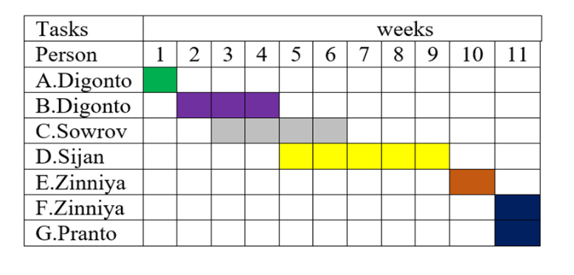

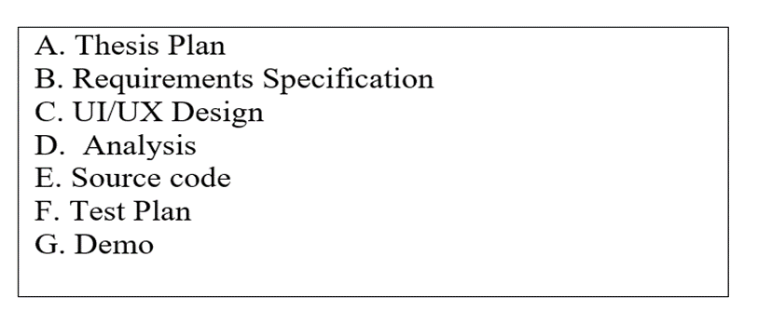

*Figure 01: Activity Planning of Digital Parking System*

## Risk Analysis

*01: Risk Management of Digital Parking System*

|  |  |  |  |  |  |
| --- | --- | --- | --- | --- | --- |
| **S/N** | **Risk Description** | **Probability** | **Impact** | **Priority** | **Mitigation Plan** |
| 1 | Unrealistic time estimation | 40% | Project will be delayed 2 months | High | Take multiple estimation |
| 2 | A team member decides to quit | 10% | Progress will be delayed | Normal | 1. Add another developer if possible 2. Open position |
| 3 | Delays in feedback or late approval from client-side | 40% | Project will be delayed several weeks | High | 1. Discovery and communication plan 2. Clearly say how delays will affect us |
| 4 | Created architecture is not scalable when developing a product | 30% | project will be delayed indefinitely | High | 1. Discuss with tech lead vision of the product, short-term and long-term 2. Review current architecture and how it should be changed 3. Add time before the start of development for creating the product architecture |
| 5 | After release users found bugs | 35% | Product will be at of rejection | High | 1. Smake testing before release for 2 environments 2. High-load testing before release 3. Acceptance testing |
| 6 | Users do not use the core functionality | 30% | Product will lose its value | Normal | 1. Define users’ needs 2. Test prototype with core functionality 3. Set up analytics to track what is being used and what’s not |
| 7 | Bad feedback about the product | 25% | Product will face loss | High | 1. Testing before the release to fix critical bugs 2. A soft launch to find and fix bugs and also receive user feedback early |